# Homework #6: User Management

|  |
| --- |
| * This is an individual assignment and is worth 20 points. * The due date is Tuesday, March 17th. * The database for the assignment - AdventureWorks2016CTP3 – in installed on our Proxmox server. You should download this document after you login to the Proxmox server. * You should answer the questions in blue. * You will get deductions if the requested screenshots are not provided. * Please zoom in your output. I will penalize you if you do not zoom in. |

# Task #4. Assigning User Mappings to Fixed Database Roles

## A. Assigning a user to a database role

## B. Verifying the results

5) Does it fail? Show the result in a screenshot. Describe your observation and explain why it fails.

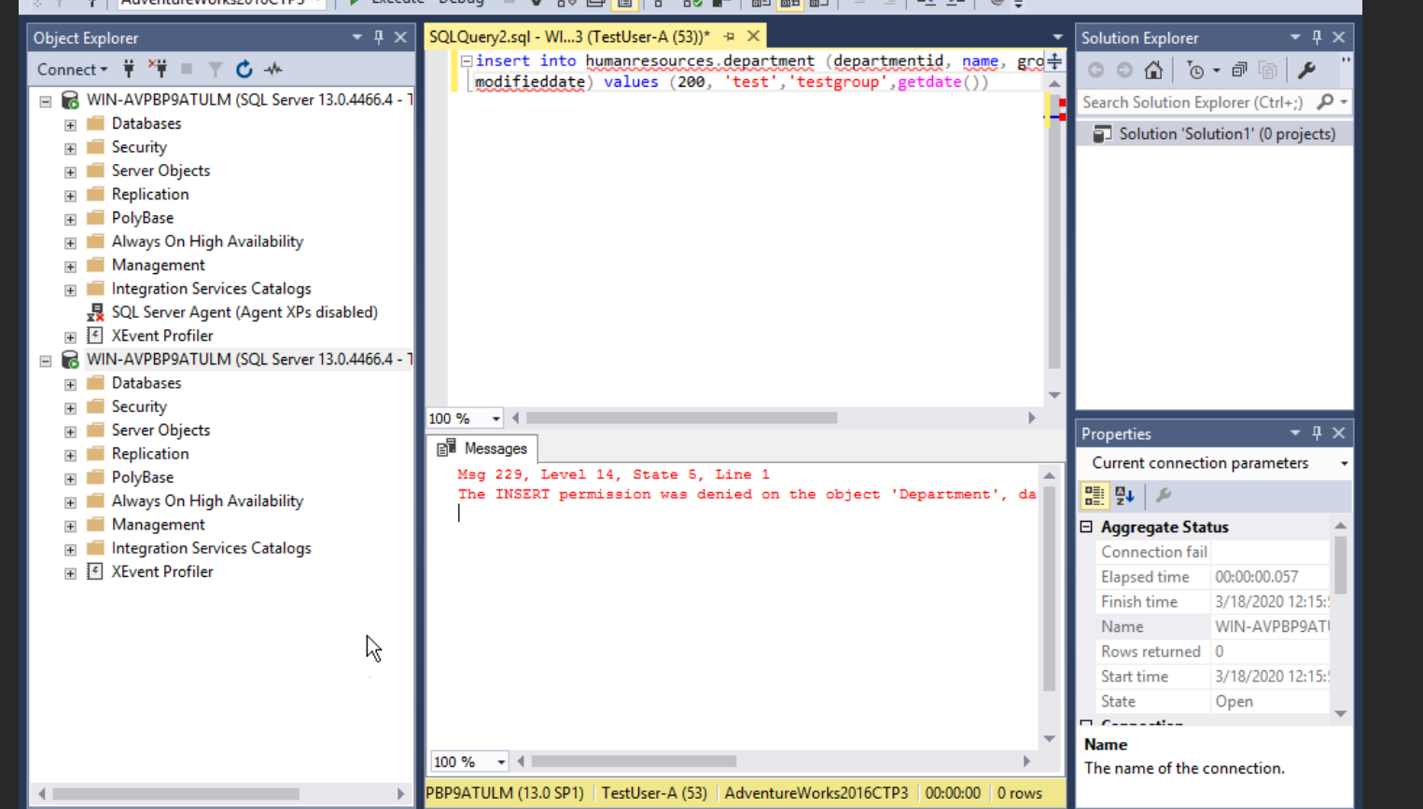

It failed because TestUser-A does not have write privileges to the database.

10) Does it fail? Show the result in a screenshot. Describe your observation and explain why it fails.

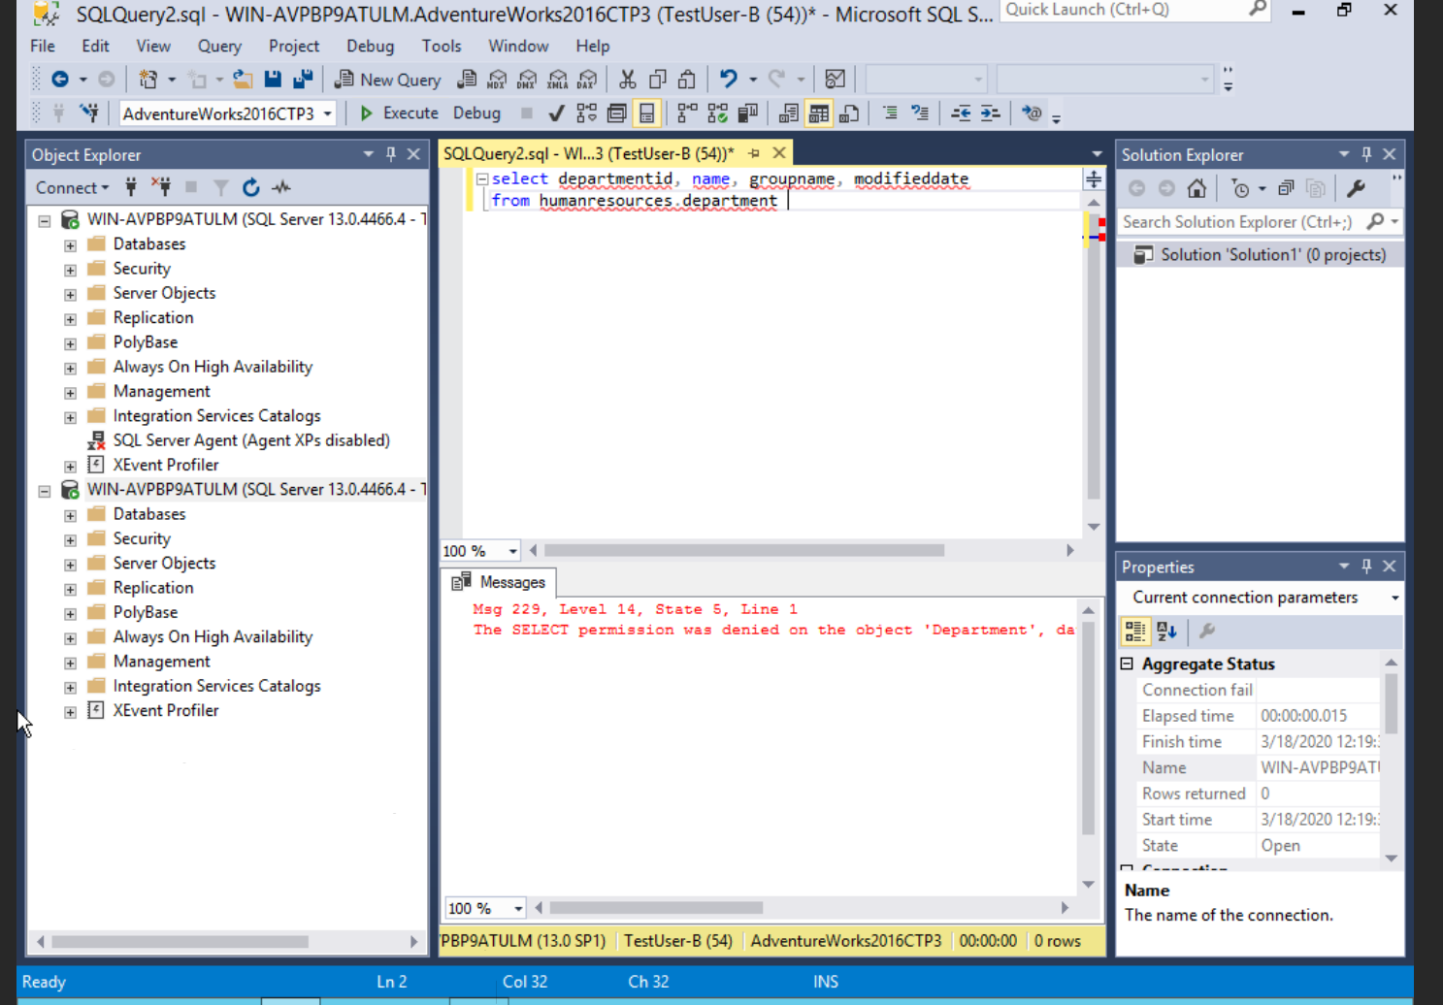

It failed because TestUser-B does not have read privileges in the database.

# Task #5. Creating a Custom Database Role

## A. Creating a custom database role

## B. Verifying results

4) Does it work? Show the result in a screenshot. Describe your observation and explain why it works.

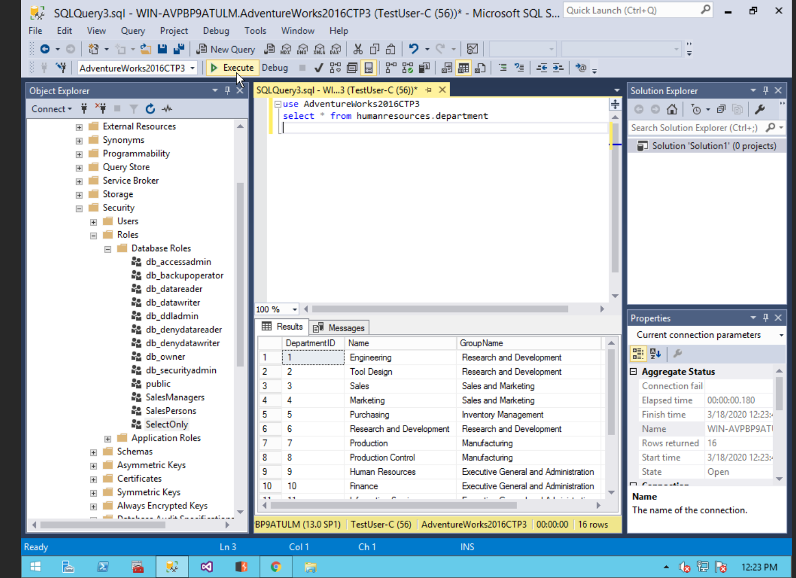

It works because we gave TestUser-C a role which allows for select options to be performed in the humanresources.departments part of the DB.

5) Does it fail? Show the result in a screenshot. Describe your observation and explain why it fails.

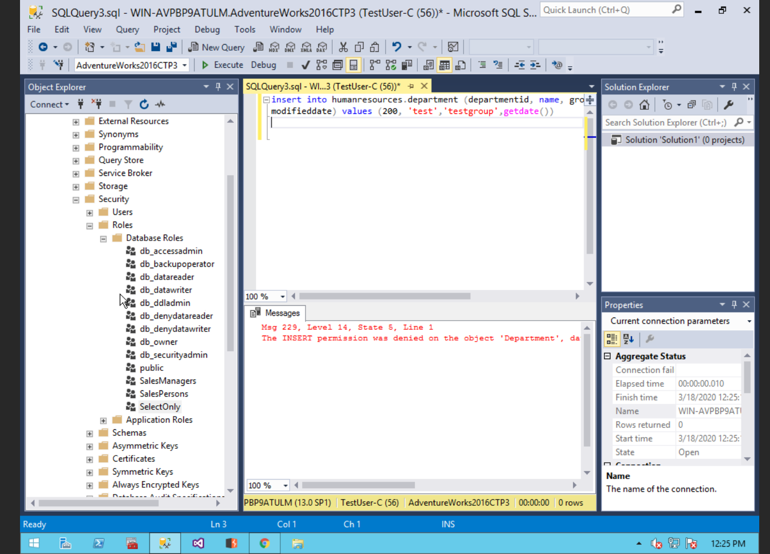

It failed because TestUser-C only has select privileges. Therefore, it cannot insert anything into the database.

# Task #6. Creating an Application Role

## A. Creating an Application Role

## B. Verifying Results

2) Does it fail? Show the result in a screenshot. Describe your observation and explain why it fails.

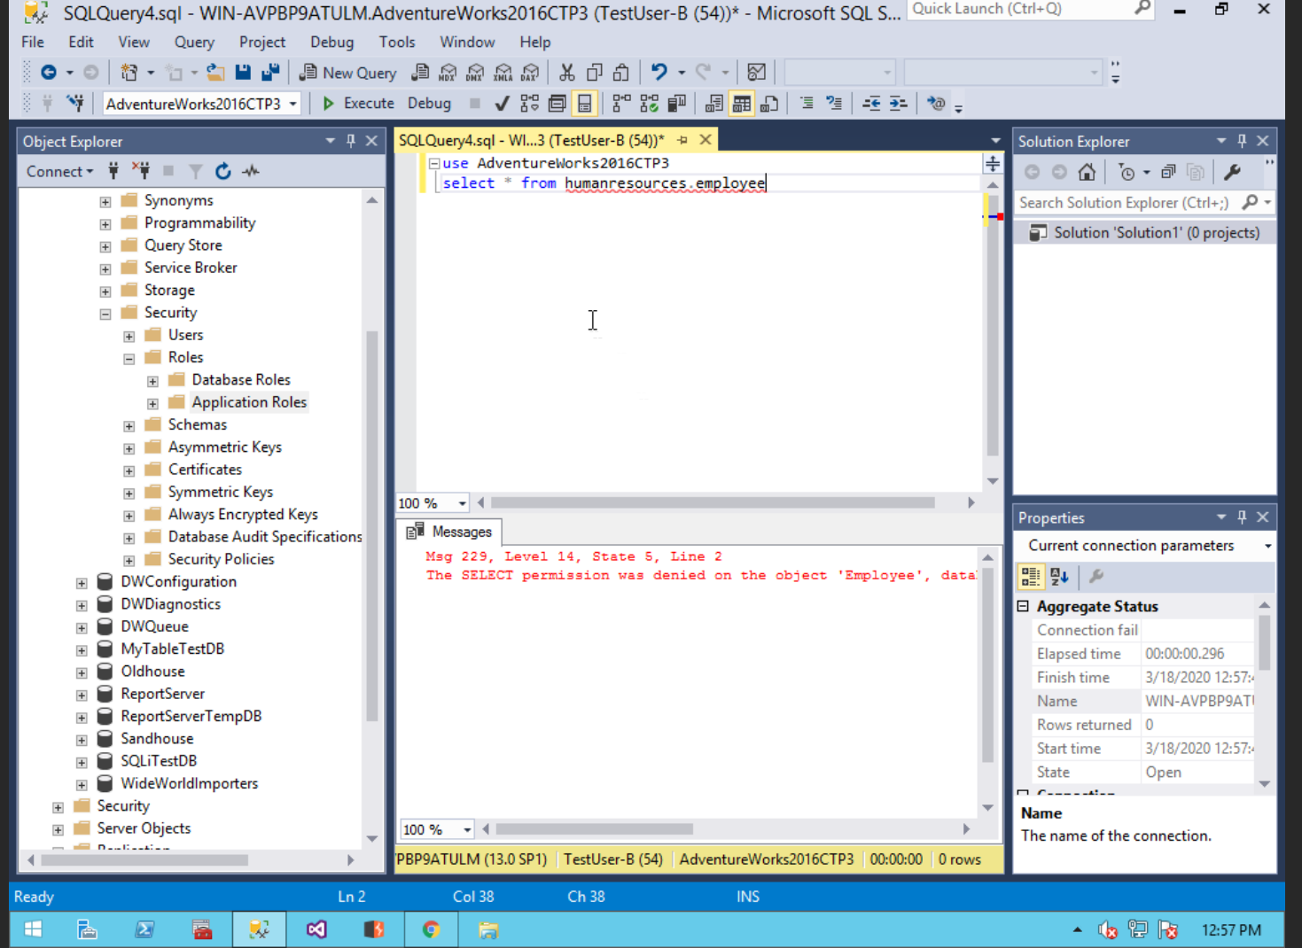

It fails because TestUser-B does not have select permission for HumanResources.Employee.

4) Does it work? Show the result in a screenshot. You have to click on Results to view the results. Describe your observation and explain why it works.

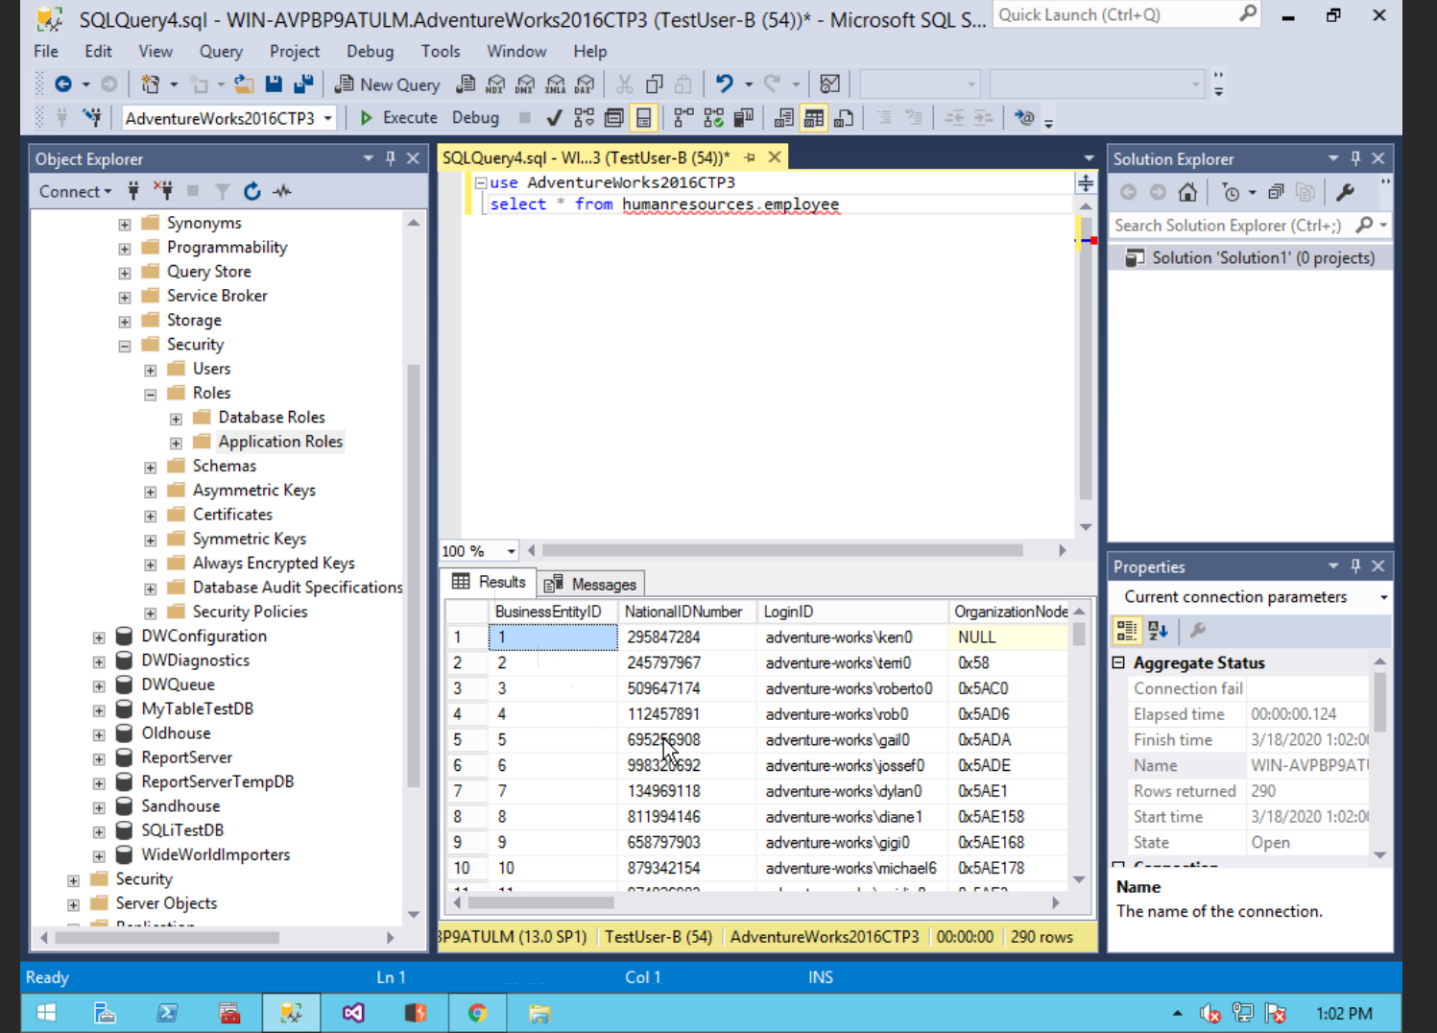

Yes, the query is now working since we gave TestUser-B SELECT permission via the application role entapprole.

# Task #7. Assigning Permissions

9) Does it work? Show the result in a screenshot. Describe your observation and explain why it works.

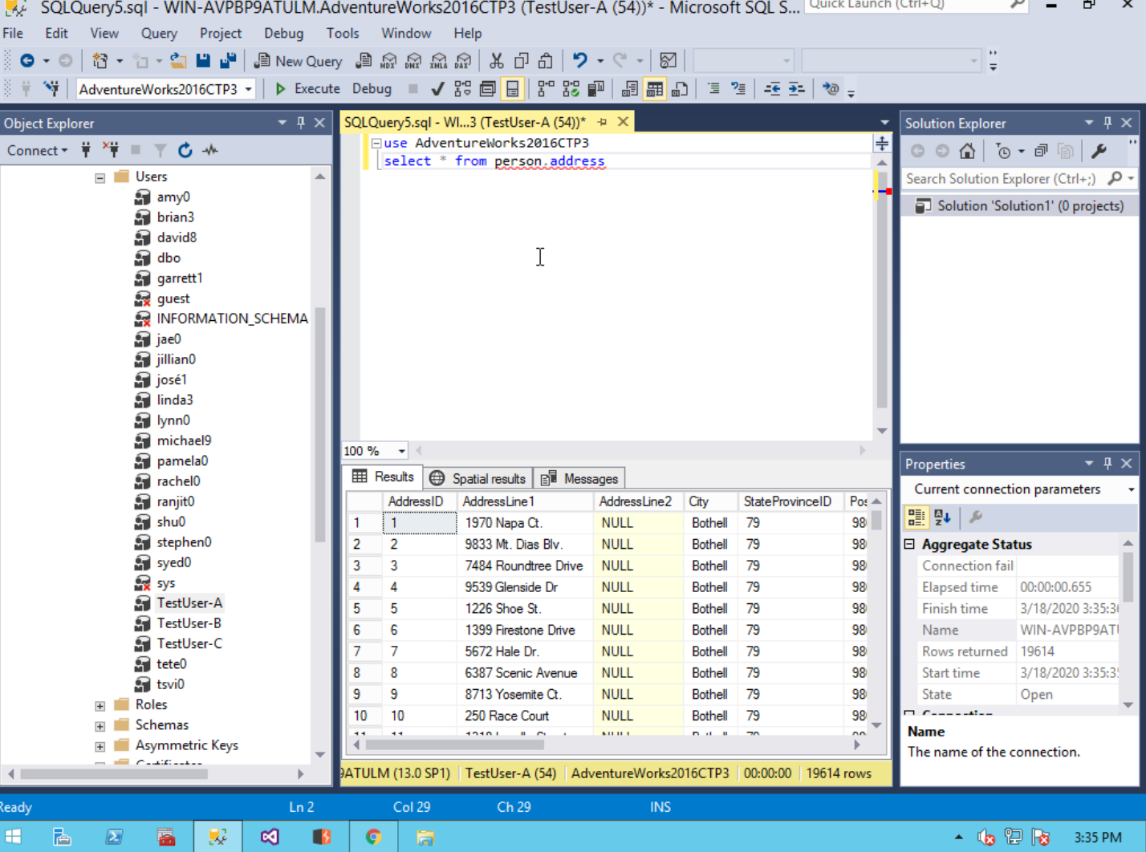

Yes, it works because TestUser-A has Select privileges on the Employee.Address portion of the database via the securables we changed in properties.

13) Run the previous query. Show the result in a screenshot. Describe your observation and explain why it fails.

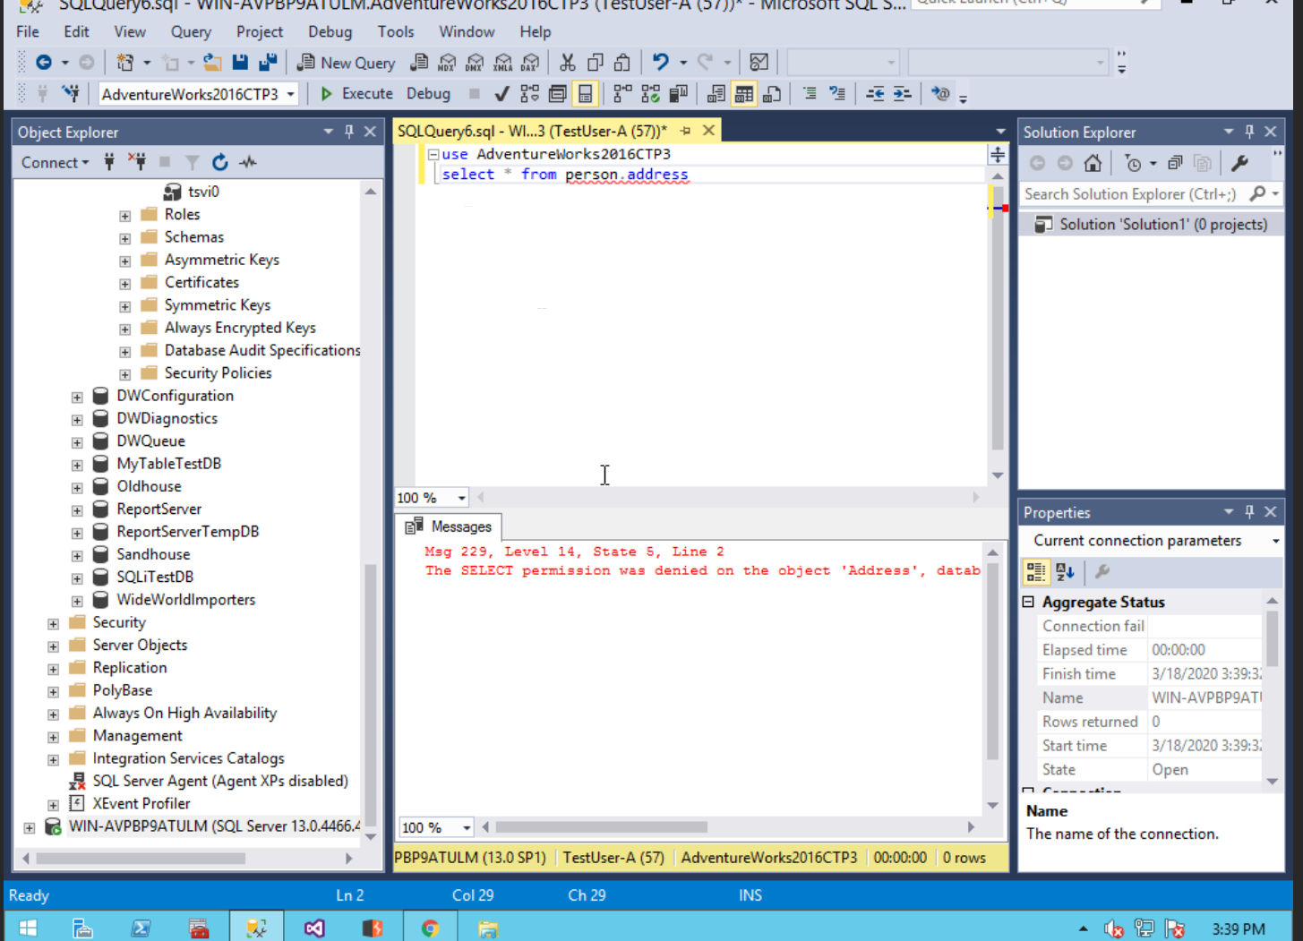

It fails to work since we removed the select privilege from TestUser-A. Therefore, we have prevented TestUser-A from being able to select data to read from the database.

15) Run the previous query. Show the result in a screenshot. Describe your observation and explain why it works.

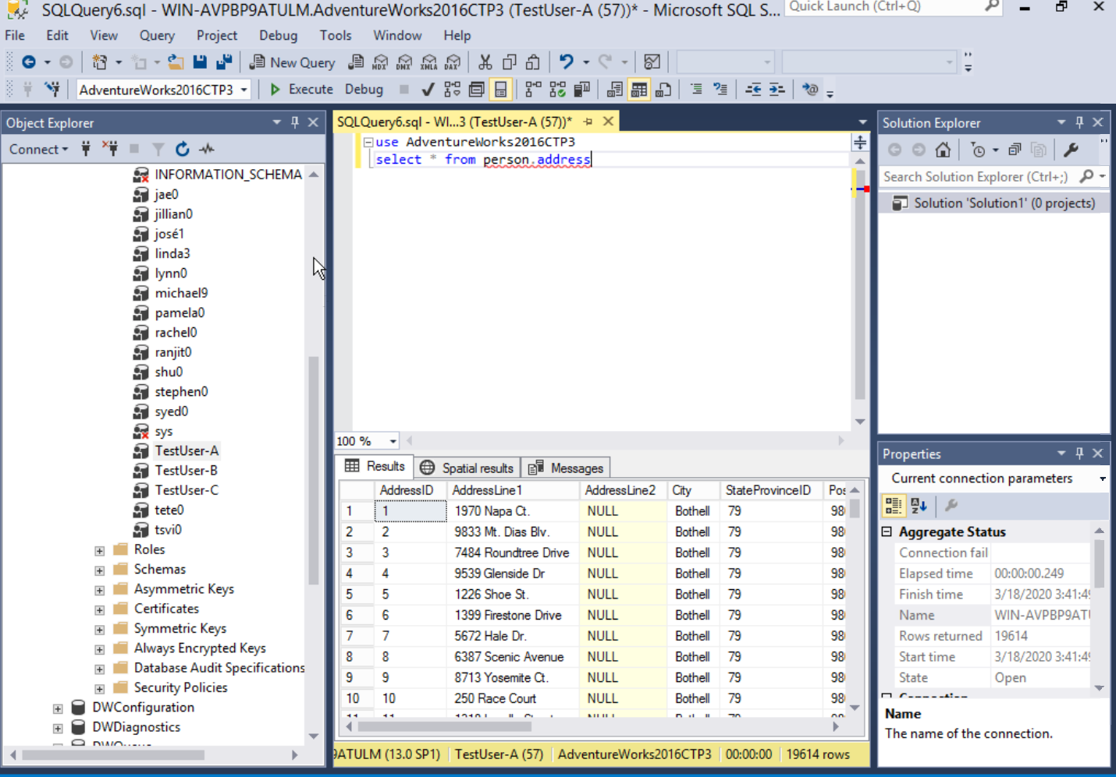

Yes, it now works since we gave TestUser-A read privilege over the entire database via db-datareader.

19) Run the previous query. Show the result in a screenshot. Describe your observation and explain why it fails.

Continues below

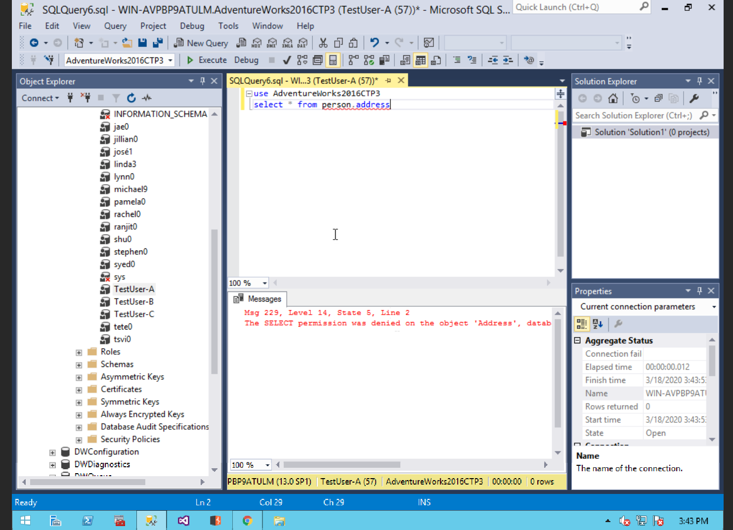

TestUser-A is unable to select from this database because we implemented deny permission on SELECT. This means even with being given db-datareader the user is still getting denied from reading person. address.